Year 3 Curriculum Newsletter to Parents
Autumn 1: Wellbeing
Bones, muscles and motion!
Wellbeing
Our whole-school topic this half term is ‘Wellbeing’. We will be carrying out a range of activities linked to this topic.

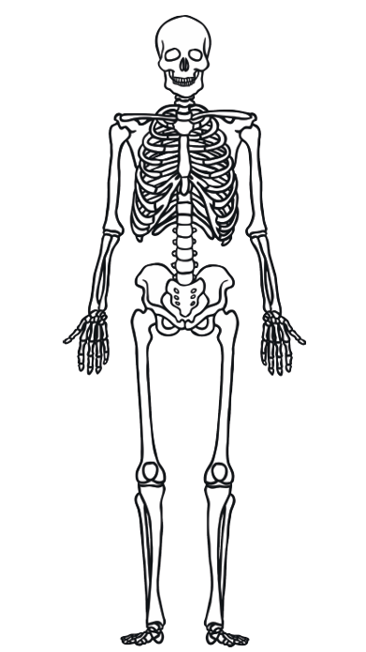

Homework
On a weekly basis, children are expected to:
- Read to an adult 5 times each week for a minimum of 10 minutes. This can be all different text types, including fiction and non-fiction. It can include reading a recipe or reading to a younger sibling!
- Practise their times tables using Times Tables Rockstars.

Children may also be given additional subject specific homework.

Dear Parents and Carers,
Welcome to Year 3! We will be starting the new school year with the topic ‘Bones, muscles and motion!’
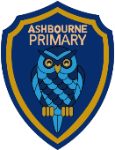
Hopefully this leaflet will give you an insight into what your child will be learning in school this half-term and provide you with some helpful ideas as to the kind of activities you could do at home to support their learning.

English and Reading
Through Grammarsaurus, Year 3 will be focusing on the place value of punctuation and grammar, including nouns and verbs. Our reading sessions will begin by introducing the Pawesome Gang who help us to answer questions and then be based on a variety of books. Towards the end of the half-term, we will be writing about how our body works and how to keep it healthy.

Maths
We will be practising skills related to place value, recognising numbers up to 1,000 at the beginning of the half term, before moving on to the four operations: addition, subtraction and multiplication and division, using formal methods to add and subtract and looking at patterns in our 2, 3, 4, 5, 8 and 10 timestables.

Topic (science)
Our Topic ‘Bones, muscles and motion’ will focus on animals including humans where we will be identifying the type of nutrition humans need and understanding that humans and some other animals have skeletons and muscles for support, protection and movement.

Design Technology
In our DT lessons, the children will be making a photo frame where they will be cutting and joining materials accurately, measuring accurately, design a product before making, evaluating and editing it.

Personal, Social, Health, & Emotional Education (PSHE)
In PSHE, our topic is ‘Me and My Relationships’ where we will be learning about positive relationships, special people, friendships and risks including dares. We will also be learning about strategies to use if they are ever made to feel uncomfortable or unsafe.

Physical Education
Our PE day will predominantly be Tuesday. Children need to have their Ashbourne Primary PE kit in school. Children will also need a reusable water bottle and trainers for outdoor PE.
Our swimming day will be a Thursday. Children must have their swimming kit, including a towel and a swimming hat, in school every Thursday.
Our indoor PE this half-term will be yoga. We will be performing a variety of yoga poses individually and collaboratively, coordinate our breathing whilst exercising and learning about the benefits of yoga.

Religious Education
This half term, we will be exploring the question ‘What does it mean to be a Chrsitian in Britain today?’ We will be understanding how, where and why Christians worship God.

Computing
Our topic in computing is desktop publishing, where children will be looking at a range of page layouts, thinking carefully about the purpose of these before using software and considering careful choices of font size, colour and type as well as adding images to create their own magazine front cover.

