Year 2 Curriculum Newsletter

Autumn 1: Knights and Castles

Dear Parents and Carers,

This half term our topic is Knights and Castles. Learning across the curriculum will link to this theme.

We have many exciting experiences this term including:
- A Medieval Banquet
- Catapult Competition
- Book Fair
- Chicks visiting school
- A poetry performance to the rest of the school

Welcome back to school, I am really looking forward to meeting you all!

Miss Keay

Here are some of the stories that we will be sharing this half term to help lead our learning:

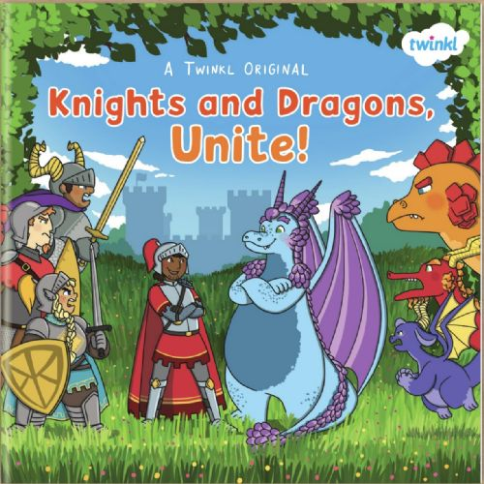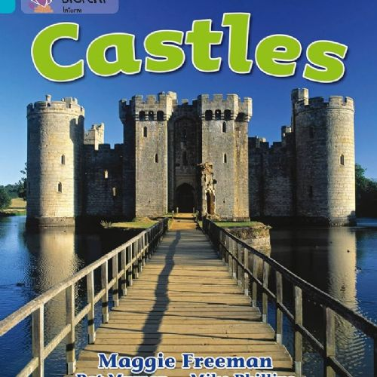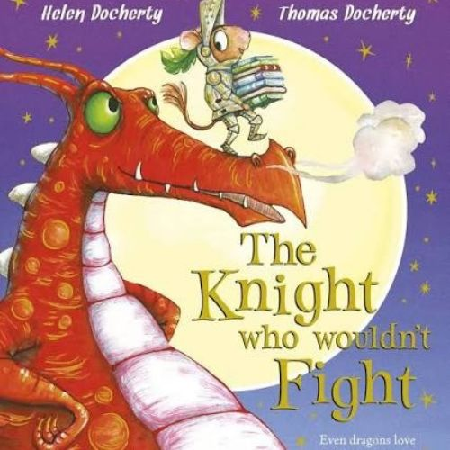

English  We will explore fiction, non-fiction and poetry. Children will publish their work by making storybooks, recording audiobooks and performing poems.  At home, you could read a story together and  encourage your child to make up their own castle  adventure. | Maths  Our focus is Place Value followed by Addition and Subtraction. We will build confidence using practical resources and reasoning.  At home, you could practise counting, recognising  numbers and solving simple addition and subtraction questions.
History  We will investigate castle life and how it has changed over time, using historical evidence, asking questions and learning vocabulary such as decades and centuries.  At home, you could look at pictures of castles and  talk about what life might have been like a long time ago. | Science  We will learn about everyday materials and continue observing seasonal changes throughout Autumn.  At home, you could go on an autumn walk and collect leaves. Talk about different materials around your  home.
Art & DT  Inspired by Paul Klee, children will create castle artwork and build catapults, exploring mechanisms, structures and evaluating their designs.  At home, you could draw or paint your own castle  using different shapes and colours. | PSHE  We will focus on feelings, friendships, self-regulation, bullying awareness and knowing who can help keep us safe.  At home, you could talk about feelings and what  makes a good friend.
PE  We will have two PE sessions per week.  On Wednesdays, Derbyshire Cricket will be teaching children outdoors.  On Fridays we will be doing indoor yoga.  At home, you could practise throwing and catching a ball or try some simple yoga stretches together. | Home Learning  Please read with your child at least five times each week and record this in their reading record.

