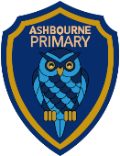

Year 6 Curriculum Newsletter to Parents

Autumn 1: Intrepid Explorers

Dear Parents and Carers,

Welcome to Year 6! We will be starting the new school year with the topic ‘Explorers!’
Hopefully this leaflet will give you an insight into what your child will be learning in school this half-term and also provide you will some helpful ideas as to the kind of activities you could do at home to support their learning.

Homework
Homework will be due in on a Friday. On a weekly basis, children are expected to:
- Read to an adult 5 times each week for a minimum of 10 minutes. By Year 6, we would expect children to be reading a wide variety of texts.
- Practise times tables weekly.
- Polar research homework will be due in on Friday 10th October. More details will follow.
Children may also be given additional subject specific homework.

Please note that there will be no weekly spelling test.
Through GaPS sessions, Year 6 will be taught the Y5/6 spellings. In place of a weekly spelling test - with aim of exposing the children to a wider vocabulary – Year 6 will instead be learning a ‘Word of the Week’. The Year 5/6 Spellings can be found on the 6B class pages of the website if you wish to do additional learning at home.

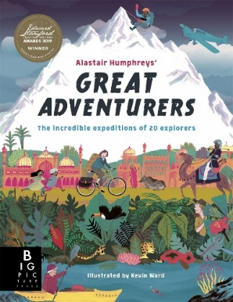
English and Reading
Through Grammarsaurus, Year 6 will be focusing on the place value of punctuation and grammar. Our reading sessions will be based on the book ‘Great Adventurers’ by Alastair Humphreys. Towards the end of the half-term, the children will be tasked with writing their own non-chronological report on explorers.

Maths
The children will be practising skills related to place value, adding, subtracting, multiplying and dividing. They will practise both mental and written methods.

Topic
Our Topic ‘Poles Apart’ will focus on the similarities and differences between the Arctic and Antarctica. As this is a Geography based topic, the children will be learning about lines of longitude and latitude and will be working with temperature data to evaluate the physical nature of the Poles. We will also investigate the impact of humans on the Poles.

Science
In Science this half-term, the children will learn about the main parts of the human circulatory system and the role of the heart, blood vessels and blood. We will also explore how food passes through the body in the digestive system. The children will also be thinking about the impact of diet, exercise, drugs and lifestyle choices on the way their bodies function.

Design Technology
During DT week, the children will be taking part in the squashed tomato challenge, where they will learn about pulleys.

Personal, Social, Health, & Emotional Education (PSHE)
In PSHE, the children will focus on relationships and how they can build. We will discuss how to resolve friendship problems and work together. The children will also examine what is meant by assertiveness and how they can practise these skills to apply in life. Towards the end of the half term, we will understand what appropriate and inappropriate behaviour is and ensure the children are confident in their understanding of consent.

Physical Education
On PE days, children need to have their Ashbourne Primary PE kit in school. Children must have trainers for outdoor PE. Children will also need a reusable water bottle.
Indoor PE this half term will be yoga. Teaching will focus on understanding the importance of breathing as well as building strength and flexibility.
For outdoor PE, the focus will be Teambuilding. We will cover the topics of communication, negotiation and collaboration through a range of activities.

Spanish
The children will learn how to describe their holiday. They will learn how to speak in the past tense and how to ask questions about others’ holidays.

Computing
The children will develop their knowledge and understanding of using a computer to produce 3D models. They will explore how to resize, duplicate, group and ungroup objects and create hollow objects.

